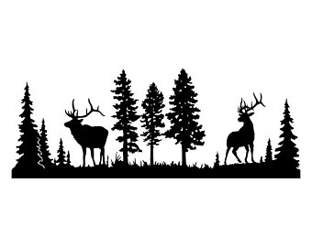

3-D Animal League

- Friday, Nov. 10
- Friday, Nov. 17
No League Nov. 24
- Friday, Dec. 1
- Friday, Dec. 8
- Friday, Dec. 15
- Friday, Dec. 22
- Friday, Dec. 29
No League Jan. 5
- Thursday, Jan. 11
- Friday, Jan. 19
- Friday, Jan. 26
AWARDS @ Banquet

$6 members $8 Non-members $4 All Youth under 18
7-9:30 PM
Nampa Bow Chief’s Indoor Range
222 Railroad Ave., Nampa, ID
You must have at least 4 arrows to shoot.
Each shooter shoots 2 targets at each numbered line (Shooter in lane 1 will shoot target 1 and 2; Shooter in lane 2 will shoot targets 3 and 4)
Shooters will be assigned a starting target. Please call to sign up.
We will be using a Handicap system and Awards will be given at the end.
To be eligible for awards Adults must attend 7 league nights: no minimum for youth.
We are also going to be doing a random x count each night. Cost $1 per night
Contact Ryan Bollar 208-869-9689 or Michelle Bollar 208-869-1878
PLEASE contact Michelle to be on the list!
